Business Plan for Online Program

LDT 540

# Executive Summary

In the wake of the pandemic, the demand for K12 virtual learning solutions remains high, with many districts continuing, and expanding, their online offerings permanently (Grimes, 2022), now is the perfect time for new online program development.

This project would create an online program manager position within the organization, who would then oversee the remainder of this project, which entails creation of our own courses, by our staff, for key courses with high demand on-site and/or vendor courses we are currently purchasing for students.

The program would begin with math and robotics, two high demand courses on site at the learning centers, and also high cost courses when purchased third party for student enrollment. Target date for the first courses released would be the 2023-24 school year. Expansion of the staff-created courses past the initial offerings would be based on demand for existing in-person courses.

This project would require the addition of an LMS system, already a planned project for implementation in the 2022-23 school year. This project would not require expansion of the current scope of that project in terms of users or storage needs.

During the implementation phase of the online courses, the online program manager would continue to oversee those courses, with the help of IT as needed, though it is likely to be minimal given current situation of hybrid and blended courses utilizing the same frameworks to be utilized in the new program. Staff and current learners have already been trained in the needed technologies.

Transition to online offerings would be a significant cost savings in terms of facilities use, given our current facilitates are operating at maximal capacity and students unable to get all the courses wanted. Expansion of facilities is proving quite costly, and difficult to achieve in both our existing sites. Transition from vendor-provided online offerings to internal offerings would also be a significant cost savings for the organization, and the internal courses would better align with the organizational vision as a whole and pedagogies.

# Overview of Project

In the wake of the pandemic, the demand for K12 virtual learning solutions remains high, with many districts continuing, and expanding, their online offerings permanently (Grimes, 2022), now is the perfect time for new online program development.

The online program this proposal covers would be a growing selection of courses created by existing staff in the organization, targeted at the currently enrolled TK-12 learners in this public charter school. These courses would be as an alternative to the currently purchased third party courses available in the TK-12 marketplace. The creation of internal options in this online program would reduce the yearly existing cost of procuring external courses for student learning plans, as well as work to reduce class sizes for existing in-person offerings, reducing the need for expansion of facilities immediately.

This project would be under a newly created position of online program manager within the framework of the organization.

## SMART Goals for this Project

1. During the 2022-23 school year, identify and develop online versions of two courses currently offered synchronously, which will be offered virtually or Hyflex for the Fall 2023 Trimester.
2. During the 2022-23 school year, implement a better data analysis strategy, built on the existing financial software, to collect information on where current spending is highest for third party vendor courses purchased for learners, to then be used to determine new internal course offering alternatives.
3. Summer of 2023, analyze the finalized data from goal #2 and the completion and outcomes from #1 to determine how many and which specific new courses should be added, along with timelines for that expansion.

# Organization

The program is within an existing TK-12 public charter school with leaners enrolled in independent learning as classified by the state in which it resides.

In this school, learners freely choose materials for each subject. These materials may include community courses by vendors/contractors, online courses from third parties, books, videos, or other materials sourced by the learner or the family of the learner in consultation with the credentialed staff overseeing each family.

This program is as an internal alternative to the online courses from third parties, or other currently utilized methodologies by learners in the independent track. It could also be utilized by the current in-person track for individuals preferring online courses. In either case, it expands the choices available to learners.

# Learner Journey Map

The following would be the learner journey map for an existing learner within our program of offerings, with specific focus on the cycle if a new online program option was chosen.

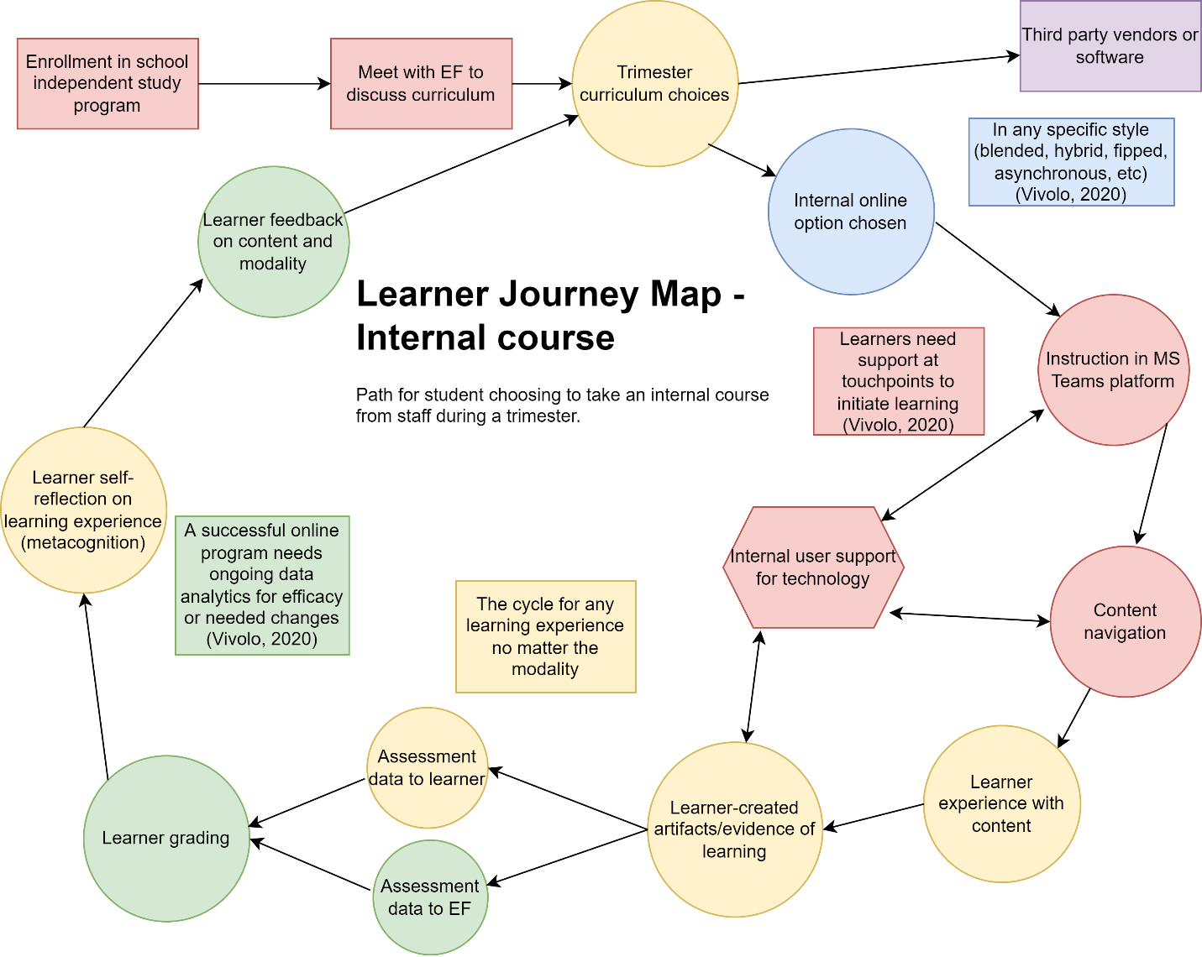

# Stakeholders and Partners

Content for this program will originate with the existing staff instructors, who are our subject matter experts (SMEs). The content currently being provided for leaners in face-to-face (F2F) synchronous methodology will be duplicated in online format.

Support for the creation of the online materials will be provided by the program manager. This support includes information regarding current best practices for online learning as well as assistance converting the content from the SMEs into online format within our existing technology infrastructure, for eventual delivery directly to the learner.

Our Informational Technology Manager will provide second level technical support as needed in hardware and software issues encountered during the transition, as well as consultation regarding possible additional needed software and/or hardware such as might be required for the creation of online content.

The entire project is under the scope of our school director regarding scope and eventual rollout, who reports to the Executive Director. The school is overseen by a school board for our school. This school is a public school so follows all laws state public schools must follow, and education laws for the Department of Education (DOE).

As this project is starting very small with one to two courses, with growth dependent on need, team members may be added as necessary at the SME level, with possible addition of a specific instructional designer in the future if workload warrants. This will need to be evaluated at the conclusion of each school year and projections of the number of courses added for the coming school year.

## Stakeholder Analysis

Mendelow's matrix of stakeholders listed as power/interest:

Low/low:  IT Manager
Low/high:  Staff; parents/students
High/low:  DOE, CDE, SDCOE, CFO
High/high:  School board, executive director, school director, program manager

## Communication Plan by Quadrant listed by Power/Interest:

**High/High:** The school board, executive director, school director and program manager are individuals with high interest in the program and also high power over the program, with the program manager the least among the group in terms of power, and the school board with the highest level of power.

School board will get monthly updates, at the regular monthly board meeting for the school board, during the portion of the meeting dedicated to updates on ongoing projects, verbally from the school director with written summary in the board packet materials for that month.

Directors and managers will be updated monthly at the regularly scheduled leadership meetings, which occur three business days prior to the school board meetings, so that the directors are properly able to do their updates at the board meetings regarding all ongoing projects.

In addition, weekly leadership meeting updates will be provided as requested and needed based on what is happening with the program. A planner document is also maintained and updated daily, shared with the directors, to show granular details on all aspects of the project and their current status.

**High/Low:** The Department of Education (DOE), California Department of Education (CDE), and our own Chief Financial Officer (CFO) are concerned that we are following the applicable federal, state and local laws, but not as concerned with the details of the project.

CFO will be updated at the regular monthly board meeting as per the above category. Directors are tasked with legal compliance reports, and will get their information from the above category means.

**Low/High:** Staff (SMEs) and parents/students would fall into the low power but high interest grouping. These groups would be updated with all other school initiative updates by trimester, via newsletter. At the initiation of the project and the conclusion of the project, there would be a town hall for the parents/students as it would represent a change in the available options provided by our school, once announcing we are developing them, and once to announce they are ready. SMEs not involved in the course offerings that round would be informed at the frequency of the parents/students.

SMEs having their courses created would obviously kept in much closer communication, and have the Planner board shared with them to see status of all aspects of the project.

In addition, those wishing more frequent updates, are always able to attend monthly board meetings for updates.

**Low/Low:** The Internet Technology Manager would have low power and low interest specifically in this project. We are currently purchasing from third party vendors with integrations/infrastructure already in place. This individual would need input at the beginning and only as needed for consultation regarding technology if the integration or implementation is going to be different than the linkages already existing for similar purchased programs. This individual also attends monthly board meetings, so would get monthly updates there as well.

# Deliverables and Technologies

## Deliverables

This program will begin with one or two online courses of content for which the completely independent track students typically arrange online courses through third party vendors. These would be chosen from the content areas of math, language arts, foreign language and technology/coding. There are existing staff within the school for all of those, and existing synchronous courses at our learning centers for those classes.

## Technology

This school is a Microsoft school with no separate LMS. The LMS implementation project is already underway at the time of this project proposal, with implementation scheduled for the 2022-23 school year. The timelines reflected in this proposal take into account that LMS implementation.

# Intellectual Property

This content is currently in use by the school in synchronous learning and under the property rights of the school, developed for and used by the school by the staff.

Any third party content within the courses (i.e., textbooks, slides, videos) are under open educational resources and license information for those products will be shown.

# Funding and Operational Support

The support for this program is covered under the current salaries of staff to start, including off season (summer) stipends already allowed for development of online programs for the following school year for the program manager.

Ongoing costs will involve reallocation from the learner budget for third party courses into the development of internal courses, and expansion of the internal offerings.

# Environmental Scan: Internal and External Factors

## Recommended Technologies

The proposed online programs can be supported by existing content creation software, Articulate 360, with the current number of licenses (3), at least for the first year, with reassessment needed at that time.

An LMS will need to be utilized for these courses. The planning for adoption of an LMS system already exists with the same timeframe as the initiation of this program, but needs for the online courses will need to be incorporated into the existing LMS requirements document. The internal programs will not change the projected number of students utilizing a school LMS though, so should have minimal impact on user data. Rather, the origin of the content will be where analysis should focus, moving from third party integration needs to content created in house.

Educational Technology supports during the recent pandemic era have grown significantly in all areas to support schools forced into virtual learning in 2019. Consequently, these new products can be utilized to continue to offer good virtual options for learners wishing to continue virtual schooling or hybrid, feeling that particular mode of learning suits them. And, post pandemic, demand is expected to remain high. (Paykamian, 2021)

## Competitors

This list of the top 5 competitors for any internal courses created is compiled from the most popular third-party vendors, both in quantity and cost, this school currently utilize for students, as documented within the existing ordering system. Offering in-house options for these programs would offer the largest cost savings over time.

1. [Art of Problem Solving](https://artofproblemsolving.com/), math and computer science
2. [Outschool](https://outschool.com/?utm_source=google&utm_medium=ads_search&utm_campaign=ucan_ls_brand_new&gclid=Cj0KCQjw_viWBhD8ARIsAH1mCd4uF2E5JGI_RO65g8t39V2cnHsjzDAc9hKWx2WM1oojjLoKGiYe47saAs8TEALw_wcB), all subjects
3. [Bravewriter](https://bravewriter.com/), language arts
4. [Time4Learning](https://www.time4learning.com/?gclid=Cj0KCQjw_viWBhD8ARIsAH1mCd4jvrPIqWlUdh_4tPdYAvtXgUKIYQVaDLm_WtXTyy_eJaq2tntcIw8aApi6EALw_wcB), all core subjects
5. [Bright Thinker](https://brightthinker.com/), all core subjects

## Programs to Deliver and Rationale

The first courses to be developed, within the first year, should be math and coding for middle school. Currently, these are the two most in demand courses, both for on-site options at existing Learning Centers, and outsourced for completely independent learning students, per enrollment numbers in course titles listed in the SIS system and enrollment system. Thus, these courses represent the largest cost both in terms of staff time teaching them synchronously, or in vendor costs for third-party courses, whether synchronous, asynchronous or hybrid.

In addition, these have existing excellent educational technology supports to facilitate asynchronous or hybrid teaching methodologies, such as Desmos, GeoGebra, and virtual coding platforms as described above. These are free for use by schools, and currently utilized for existing in-person synchronous courses at the learning centers. This situation facilitates adapting these particular courses to online format.

Lastly, the staff instructors supporting these courses in person currently are the staff members with the highest comfort level regarding educational technology use. These staff members will be the ones best able to partner with the program manager to develop an online course.

This school is unique in its philosophy to learning personalized education for each student, with an extremely strong focus on developing student agency and encouraging them to become a self-determined learner. As many districts and individual schools are discovering, with the current use of third-party vendors for coursework, it is not always possible to find good vendor programs that align with our philosophy, which is allowing as much choice as possible within the framework of content standards for the state of California. (Hennick, 2021) Developing internal courses would allow much more adherence to the school philosophy, including multidisciplinary integration in coursework (e.g., project-based learning, problem-based learning).

## Ideal Learner

The ideal learner for this program would be students currently enrolled in independent study only track. These students in internal school surveys reported physically driving to a learning center was not desirable for a multitude of reasons including distance, cost, lack of transportation in general, scheduling conflicts and social emotional issues such as social anxiety related to in-person coursework. These mirror the larger K-12 population, across the United States, prior to the pandemic, and have only increased in number, with indications demand will remain high. (Torchia, 2021)

This group of learners represents the current largest group utilizing third party vendor solutions as described in the competitors section. They already use and enjoy completely online programs for their learning within our program.

# Marketing Methods

## Target Learner

The ideal learner for this program, as described in the environmental scan document, would be students currently enrolled in the independent study only track.

This group of learners among the current student population represents the largest group utilizing third party vendor solutions in their personalized learning plans. School funding is utilized to purchase all the needed curriculum, courses and materials needed to achieve a student’s learning plan. Thus, converting this group from external third party choices to an internal online program would be a significant cost savings for the organization.

As these users are still minors, it would be the parent/guardian of the student who would become the target audience for the marketing, rather than the target learner themselves.

Social Media

The target audience, the parents, are Millennials or Generation X categories, with the majority being Millennials. While Millennials use a wide variety of social media, 87% use Facebook (FB) at least once a week (Digital Media Ninjas, 2021).  Noted is that they also use social media to contact their research regarding a product, and ask their peers on social media for reviews. (Digital Media Ninjas, 2021)  There exist already both general homeschooling/independent study groups for the area where our school is located, and specific parent groups on Facebook for our community of parents. All of these groups mentioned have high traffic already.

As such, the organization currently advertises the school itself via programmatic ads on Facebook. This has so far given us the largest return on investment (ROI) in marketing for drawing parents to our school as a whole. This specific online program could be incorporated into the existing ads for the school as a whole when looking at adding new families to this organization.

Within the FB group for parents of the school already, staff post updates and highlight external resources for the parents.  In the marketing of the new online program, staff would need to highlight this new option available. Over time, the ideal situation would be that the first users of the new online program, would then begin to recommend it as a good alternative to the third party vendors.  As the actual users of the new program begin to promote it themselves within the groups, staff would no longer need to do that.

## Targeted Direct Marketing (in person)

Currently, the second best marketing method for this organization is targeted direct marketing, based on data collected over the last 3 years. Many of the organization’s staff have students in the school, and thus participate as parents in the same groups as our potential new families. As above, the largest percentage of targeted parents are Millennials, who are shown to be responsive to reviews, with 68% reporting they won’t make major decisions without discussion among peer groups. (Lister, 2022)

As above, the school is already utilizing a social media campaign with programmatic marketing, as well as reviews via FB groups. This is extended currently to flyers, postcards and business cards available to staff and current user base. On each is a QR code call to action to get more information immediately.

For the new online program, the tactic should be to analyze what key word variations are currently producing the best response (from internal data, those are “personalized” and “robotics”). The online program offering that will replace third party vendor options is created as cost savings, but also so the organization can incorporate those values of the school into each offered course. These values include extreme levels of personalization. As this is also a keyword valued by the target audience, direct marketing materials should highlight how this new online program enhances the ability to offer personalization for each student.

Tied to both of the above (social media and direct marketing), the landing page for the QR code call to action should be updated to immediately highlight those items that brought the customers to the site, via ongoing analytics of the website, and adjustment of the landing page organization as needed. (Schultz & Mork, 2021)

## SMART Goals for Marketing Success:

1. During the 2022-23 school year, begin marketing of coming new online program available in the 2023-24 school year, via the existing marketing channels, and evaluate results of the specific new keywords included, to guide future marketing via keyword adjustments and refinement.
2. During the first trimester of the 2022-23 school year, highlight the new online program on the landing page from marketing call to action of the organization website, and analyze page view and time spent on page trends as a result, with iterative adjustments based on results.
3. During the first year of deployment of the new online program, 2023-2024, continue marketing based on #1, analyzing changes in traffic between the time period above and this time period, paying particular attention to whether social media advertising is beginning to display current users of the new program recommending it to others (effectiveness of marketing strategy #1 in this document).

# Measures of Success

The following table summarizes key measures of success for this program.

|  |  |  |
| --- | --- | --- |
| Goal | Measure | Timing |
| Launch of program with limited courses in high demand subjects (math, coding) | At least 5 students enroll per course, our minimum for a course to proceed. | Fall of 2023 trimester |
| Reduction in per student cost per trimester | 10% reduction of per student cost for students choosing to participate in the new online offerings as opposed to in-person or 3rd party offerings. | 2023-24 school year by trimester compared to 2022-23, matching the same trimester, i.e. Spring trimester 2024 compared to Spring trimester 2023. |
| Reduction in average in-person class sizes | Class size reduction by 10% due to students choosing to take online courses as opposed to in-person courses at impacted campuses/classrooms | 2023-24 school year data compared to 2022-23, matching by same trimester. |
| Parent and student responses favorable to new offerings | Overall favorable response to new online program offerings in 2023-24 as polled via the annual Spring 2024 parent/family satisfaction survey. Specific questions related to impression and if parents found the courses useful and desirable should be included, as typically done for each new offering. | Spring 2024 |
| Minimal impact on overall technical support required | Survey of number of trouble tickets open in the internal IT support system, with goal being no more than 10% increase in overall technology support required at the learner and staff support level for specifically the online program. | Start Fall 2023, and ongoing comparison of current averages based on averages the prior year, adjusted for student enrollment numbers. |

# Summary

This addition of an online program would expand the options available for a learner within this program, thus fitting within the organizational vision of allowing maximal possible customization in this school which is dedicated to individualized education.

In addition, the online options would offer alternatives to the existing third party vendor courses online, which are both expensive and not always taught the way our own staff would teach these courses, meaning they don’t align to this school’s trimester schedule, the overarching goals for existing students (mastery, autonomy and purpose in pursuit of creating a self-determined learner), or align with the pedagogy preferred in the organization.

Any learning center track students choosing this route from home would also help reduce the number of students per class on site in a similar course, something with multiple benefits. (Barnum, 2022) The switch to online versions is a way to reduce class size without needing additional facilities/classrooms or staff for those classrooms.

This would require the creation of a new position of online program manager to oversee this project, both during implementation as well as ongoing. The cost of that salary would be offset by the savings in both facilities for new classes and in purchasing vendor courses.

# Questions or Comments?

Please contact Tanya Lake, EdTech Manager, [tanyalake@sandiego.edu](mailto:tanyalake@sandiego.edu)

# References

Barnum, M. (2022, June 10). *Does Class Size Really Matter? A Chalkbeat Look at the Research*. Chalkbeat. <https://www.chalkbeat.org/2022/6/10/23162544/class-size-research#:~:text=Research%20suggests%20that%20students%20perform%20better%20in%20smaller%20classes.&text=There's%20little%20debate%20among%20teachers,would%20strongly%20boost%20student%20learning.>

Digital Media Ninjas.  (2021, May 25).  What Social Media Do Millennials Use?  Digital Media Ninjas.  <https://digitalmedianinja.com/what-social-media-do-millennials-use/>

Grimes, B. (2022, July 14). *Districts Bet on Tech and Physical Classrooms to Boost Online Learning Quality*. EdTech: Focus on K-12. <https://edtechmagazine.com/k12/article/2022/07/districts-bet-tech-and-physical-classrooms-boost-online-learning-quality>

Hennick, C. (2021, June 25). *The Rise of Virtual-Only K-12 Schools.* EdTech: Focus on K-12. <https://edtechmagazine.com/k12/article/2021/06/rise-virtual-only-k-12-schools>

Hillman, D., Schudy, R., & Temkin, A. (2020). *Best Practices for Administering Online Programs.* Routledge.

Lister, M. (2022, May 23). *Generational Marketing: How to Target Millennials, Gen X, & Boomers*. WordStream. <https://www.wordstream.com/blog/ws/generational-marketing-tactics>

Paykamian, B. (2021, March 24). *Virtual Schools to be Increasingly Common After COVID-19.* Government Technology. <https://www.govtech.com/education/k-12/virtual-schools-to-be-increasingly-common-after-covid-19.html>

Schultz, A. & Mork, R. (2021) Marketing and Recruitment. In Cifuentes, L. (Ed), *A Guide to Administering Distance Learning* (pp. 250-286). Brill. DOI: 10.1163/9789004471382_011

Torchia, R. (2021, April 26*). Is Virtual Learning Here to Stay for K-12?* EdTech: Focus on K-12. <https://edtechmagazine.com/k12/article/2021/04/virtual-learning-here-stay-k-12-perfcon>

Vivolo, J. (Ed.). (2020).  *Managing Online Learning:  The Life-Cycle of Successful Programs.*  Routledge.